**Nginx Task01**

**create basic website to print hello sprints in index.html**

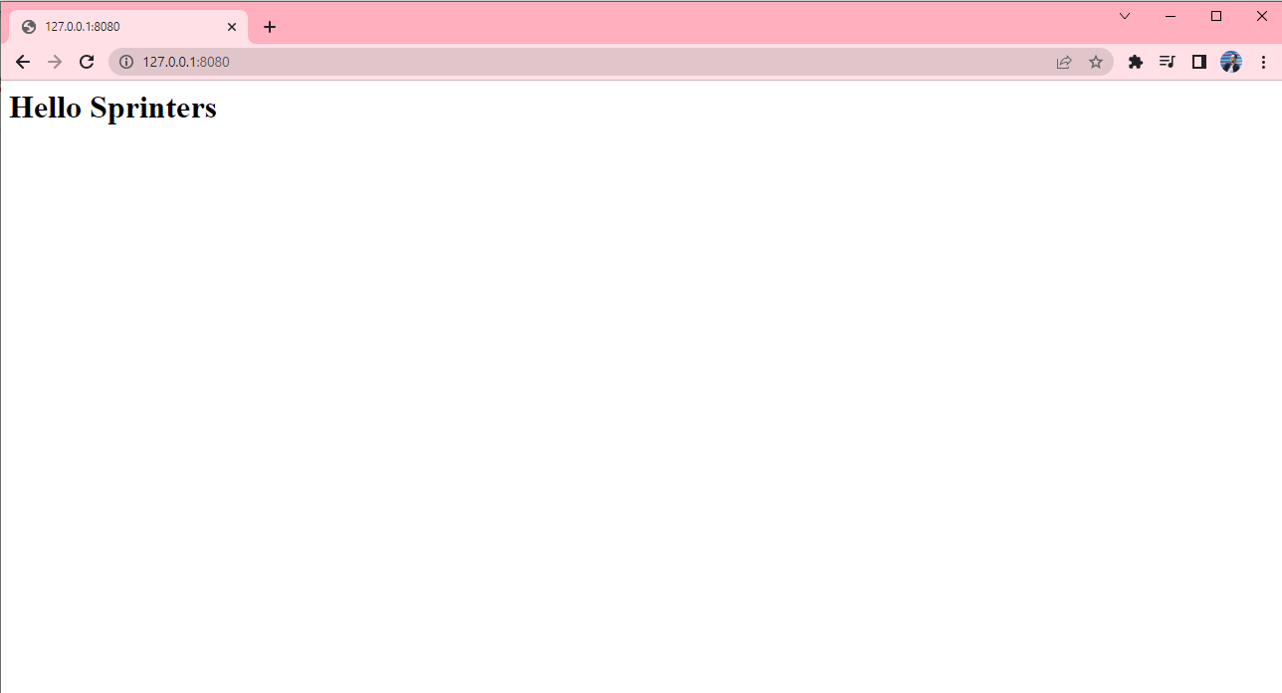

**Root oath configuration to index.html**

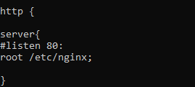

**Index.html path location**

